ANNOUNCING THE PUBLICATION OF THE ROBERT INDIANA CATALOGUE RAISONNÉ
Digital Publication Offers Comprehensive Information on
Indiana’s Paintings and Sculpture 1955-2007
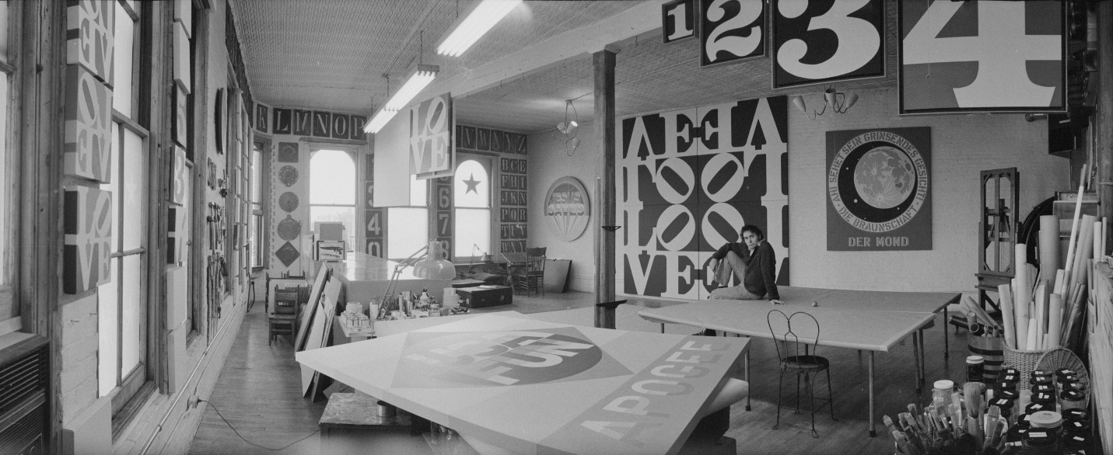
Robert Indiana in his studio at 2 Spring Street, New York, 1971.

NEW YORK, NY, NOVEMBER 17, 2023—The Robert Indiana Catalogue Raisonné, an ongoing project dedicated to documenting the artistic practice of American artist Robert Indiana (b. 1928, d. 2018), is now available online at robertindiana.com. Published by RI Catalogue Raisonné LLC using Panopticon software, and authored by Simon Salama-Caro, founder of the Robert Indiana Legacy Initiative, this free digital publication documents the artist’s paintings and sculpture conceived between 1955 and 2007.

“We are excited to share this new resource for the continued study and celebration of the work of Robert Indiana, one of America’s most influential artists,” said Simon Salama-Caro, who was entrusted by the artist in 1998 to prepare a catalogue raisonné of his work. “We hope that scholars, educators, arts professionals, and anyone wishing to gain a refined knowledge of the work of Indiana will use this new tool to learn about the breadth and depth of his oeuvre.”
Works included in the publication are paintings and sculpture that have been clearly documented through the artist’s records, gallery records, or fabricators’ records. The catalogue’s digital format allows for updated information to be added as it becomes available. This progressive approach to publishing enables greater and more immediate access to research as it develops.
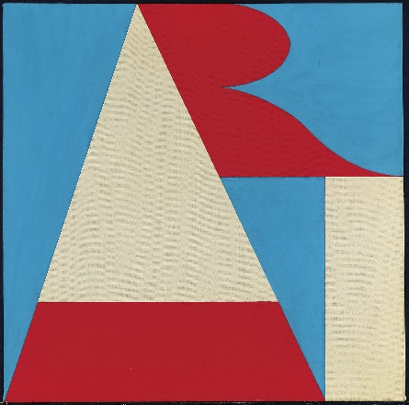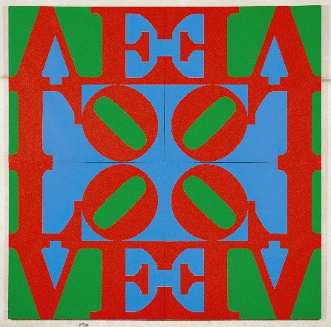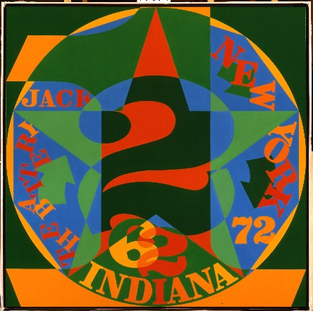

The Catalogue Raisonné is divided into five sections:

- Works, divided into Painting and Sculpture, provides information on all artwork entries along with full-color reproductions
- Chronology offers an extensive overview of Indiana’s life and career, detailing the connections between the biography and the artworks
- Exhibition History includes information about solo and group exhibitions in which Indiana’s work has been included
- Literature includes published references, a selective bibliography, archival sources, artist's statements, and a selection of pages from Indiana's journals
- and Collections includes an international list of all known public collections that hold paintings and/or sculpture by Indiana.

In the future, RI Catalogue Raisonné LLC intends to add a digital volume on works on paper and an update for prints.
RI Catalogue Raisonné LLC does not authenticate or provide valuations of works of art by Robert Indiana.

About Robert Indiana

Robert Indiana (b.1928-d.2018), one of the preeminent figures in American art since the 1960s, played a central role in the development of assemblage art, hard-edge painting, and Pop art. A self-proclaimed “American painter of signs,” Indiana created a highly original body of work that explores American identity, personal history, and the power of abstraction and language, establishing an important legacy that resonates in the work of many contemporary artists who make the written word a central element of their oeuvre.
Indiana’s artwork has been featured in numerous solo and group exhibitions around the world, and his works are in the permanent collections of important museums such as the Museum of Modern Art and the Whitney Museum of American Art in New York; the National Gallery of Art, the Hirshhorn Museum and Sculpture Garden, and the Smithsonian Museum of American Art in Washington, D.C.; the Albright-Knox Art Gallery in Buffalo, New York; the San Francisco Museum of Modern Art; the Menil Collection in Houston; the Currier Museum of Art, Manchester, New Hampshire; the Museum Ludwig in Cologne, Germany; the Van Abbemuseum in Eindhoven, the Netherlands; the Museum Ludwig in Vienna, Austria; the Art Museum of Ontario in Toronto; and the Israel Museum in Jerusalem.
About the Robert Indiana Legacy Initiative

Established in 2022, The Robert Indiana Legacy Initiative, LLC aims to increase awareness of and
appreciation for the depth and breadth of the work of Robert Indiana.
Addressing curators and scholars, collectors, art-market professionals and the public at large,
The Robert Indiana Legacy Initiative
- maintains a collection and archive of Robert Indiana’s art
- encourages and supports exhibitions and public installations of Indiana’s work
- assists with and promotes scholarly research on Indiana and his artistic career
- manages the website www.robertindiana.com and distributes a newsletter
The Robert Indiana Legacy Initiative was founded by Simon Salama-Caro, who began working as a gallerist with Robert Indiana in 1988, devoting the next few decades to safeguarding and advancing Indiana’s artistic achievement. From 1995 onward, Salama-Caro worked with Indiana as his exclusive world-wide representative for the authorized production, sale and promotion of such Indiana sculpture series as LOVE (1966), ART (1972), AHAVA (1977), ONE Through ZERO (The Ten Numbers) (1978)
and AMOR (1998).
Simon Salama-Caro and his family work closely and collaboratively with the Star of Hope Foundation, a
not-for-profit organization created in Vinalhaven, Maine by Robert Indiana. Royalties from the sale of
works in sculpture series offered through Salama-Caro and from a licensing agreement managed by the
family help fund the Star of Hope Foundation’s arts-related programs.
Media Contact:
Kara Bloomgarden-Smoke
Polskin Arts
Kara.smoke@finnpartners.com
917.864.8899

Image Credits:
Top: Eliot Elisofon; Eliot Elisofon Papers and Photography Collection, 1930-1988, undated [bulk 1942-1973]. The University of Texas at Austin, Harry Ransom Center)

Artwork: (Left to right) Robert Indiana ART, 1970, oil on canvas, 24 x 24 inches. 2) Robert Indiana, LOVE Wall, 1966, oil on canvas, Four panels, overall: 120 1/2 × 120 1/2 inches, Robert Indiana, Decade Autoportrait: 1962, 1977, oil on canvas, 72 x 72 inches. All artwork ©Morgan Art Foundation LLC/Artists Rights Society (ARS), NY

